**OPERATING SYSTEM - CS23431**

**EXP 1(B)**

**BASIC LINUX COMMANDS**

**NAME: S.G.LOGAPRIYA ROLL NO: 230701164**

**GENERAL PURPOSE COMMANDS:**

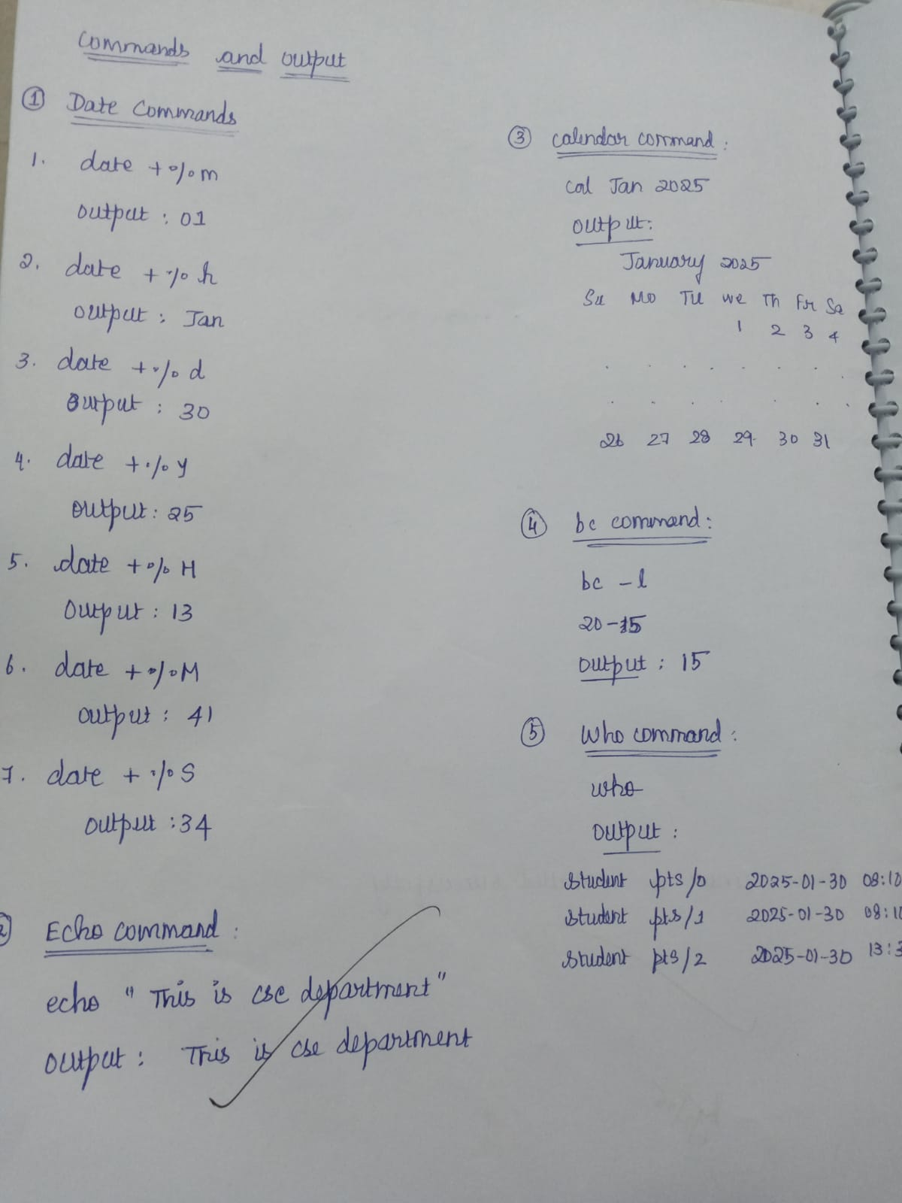

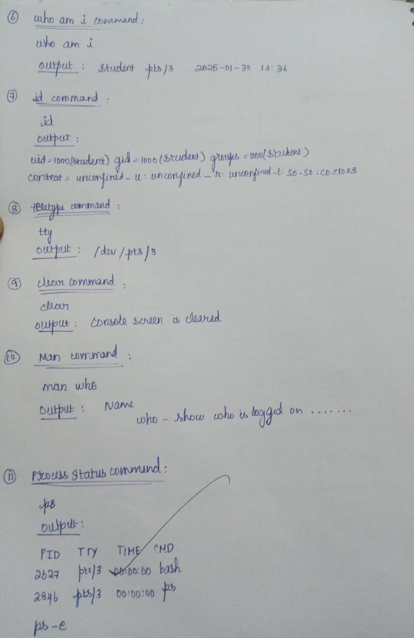

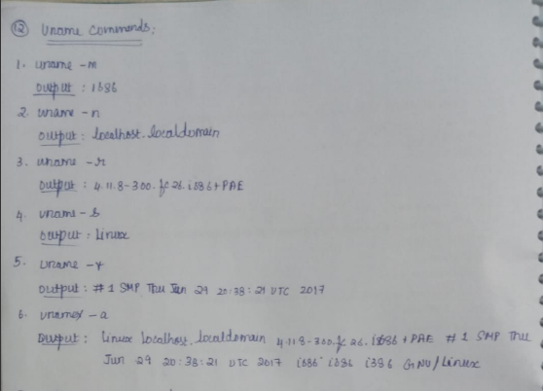

**DIRECTORY COMMANDS:**

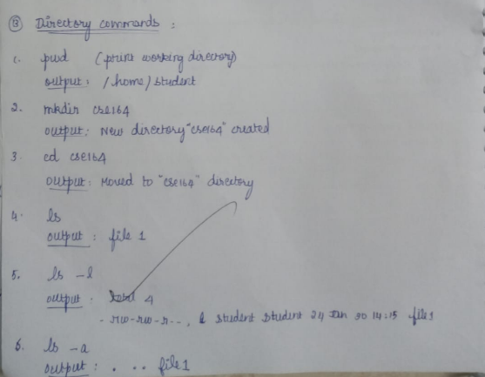

**FILE HANDLING COMMANDS:**

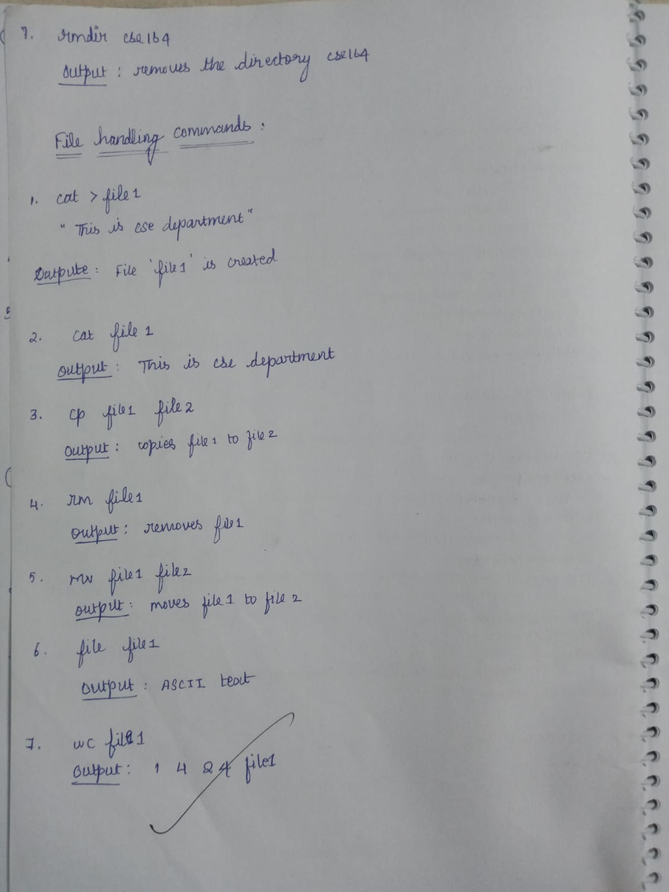

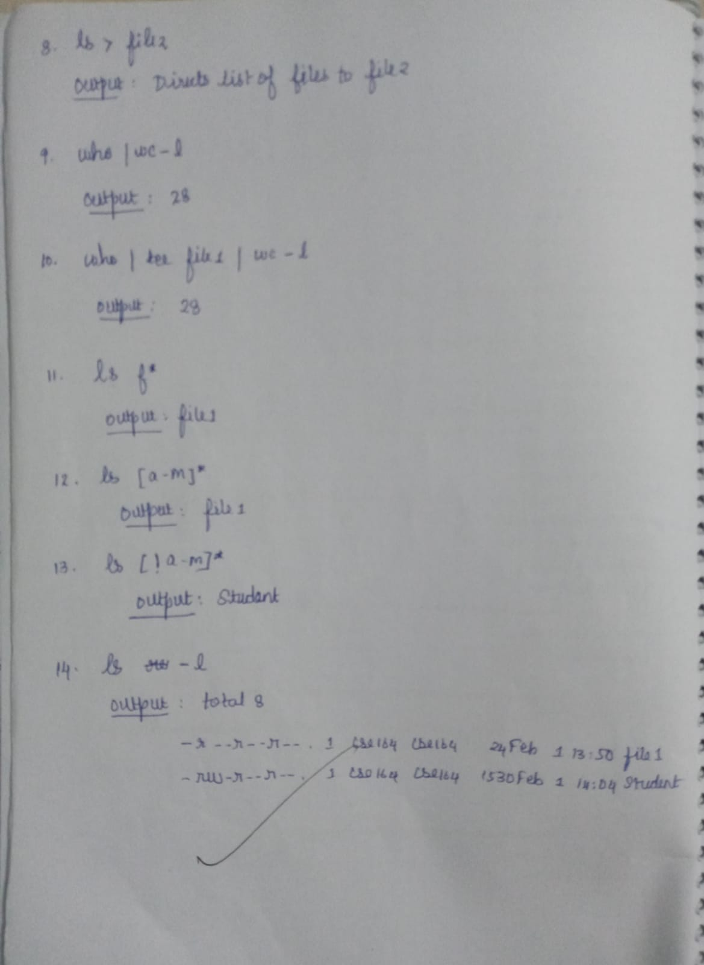

**GROUPING COMMANDS:**

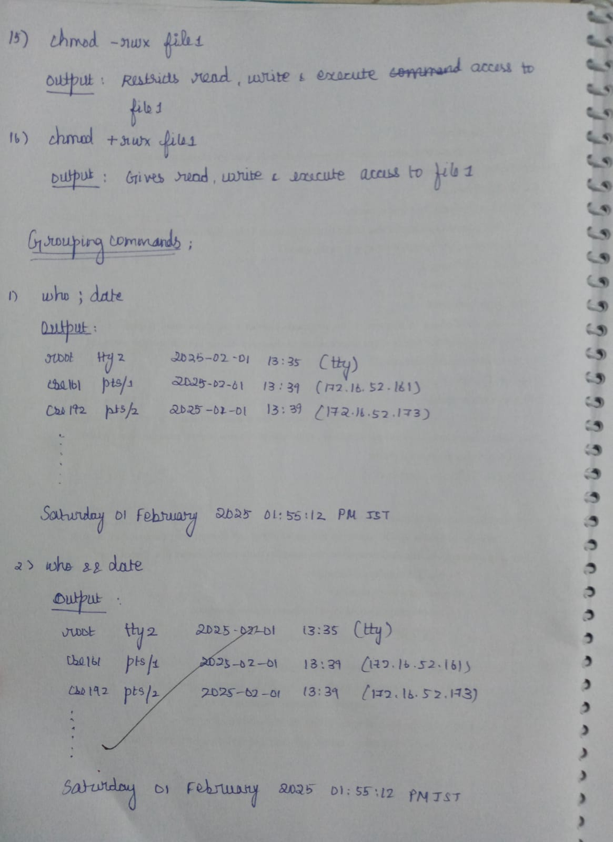

**FILTER COMMANDS:**

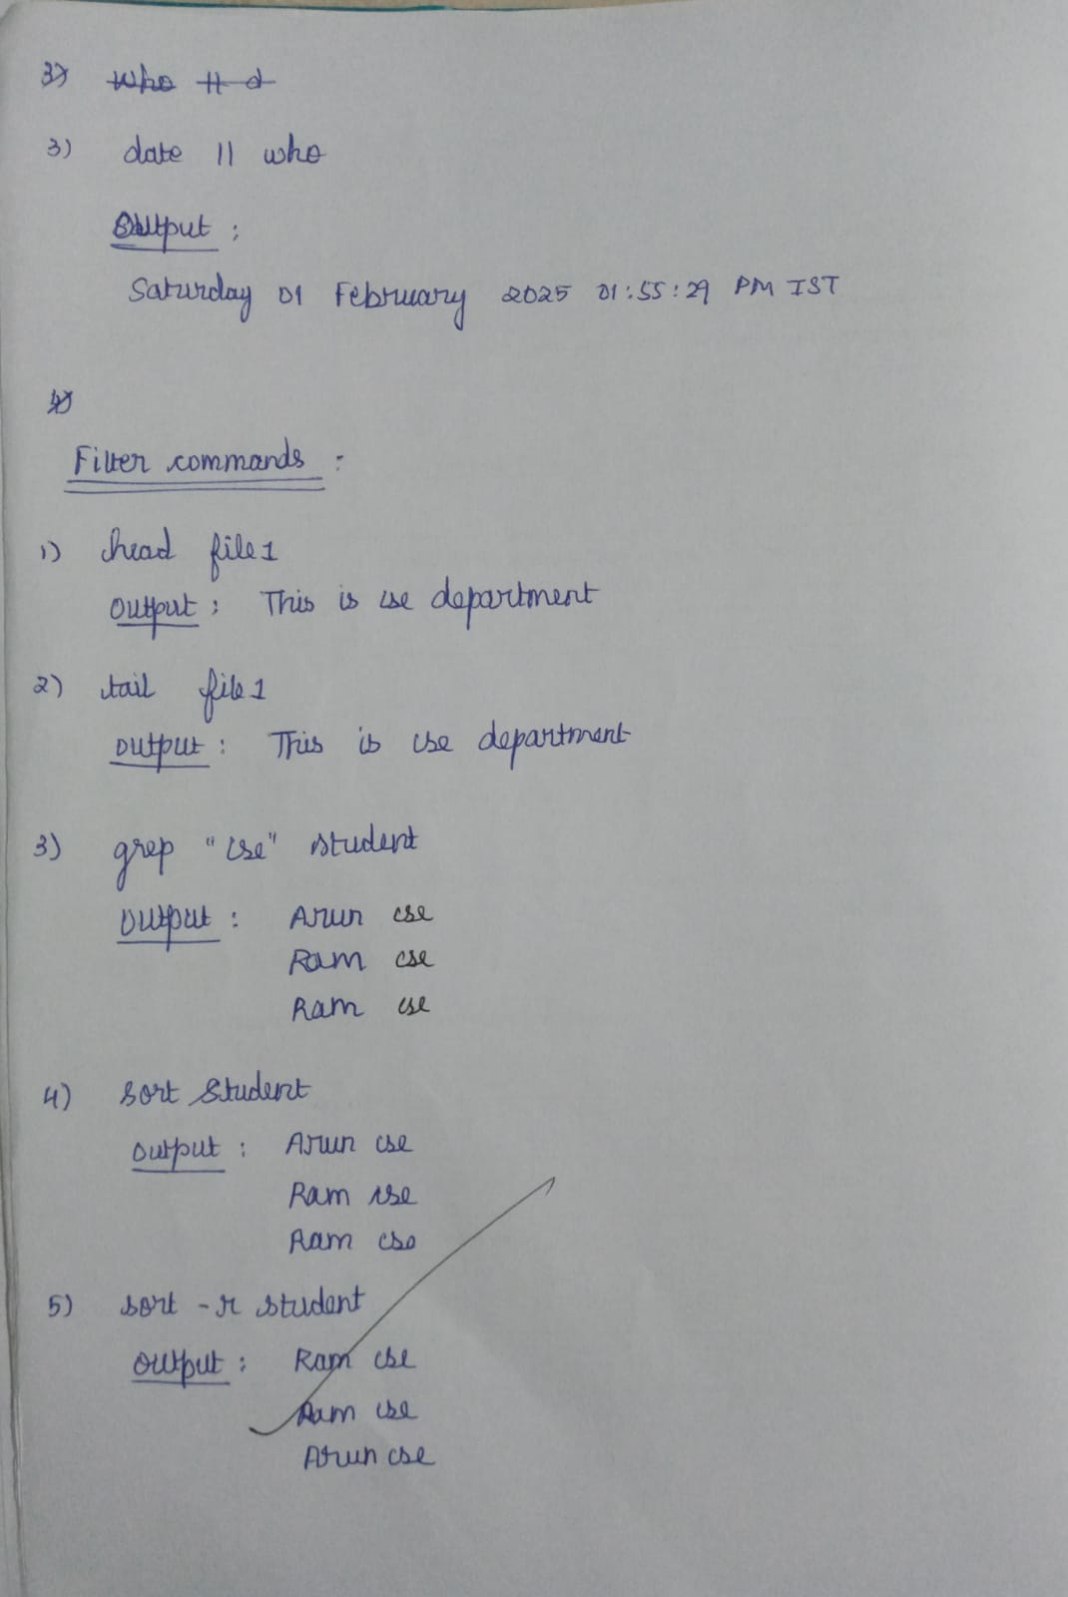

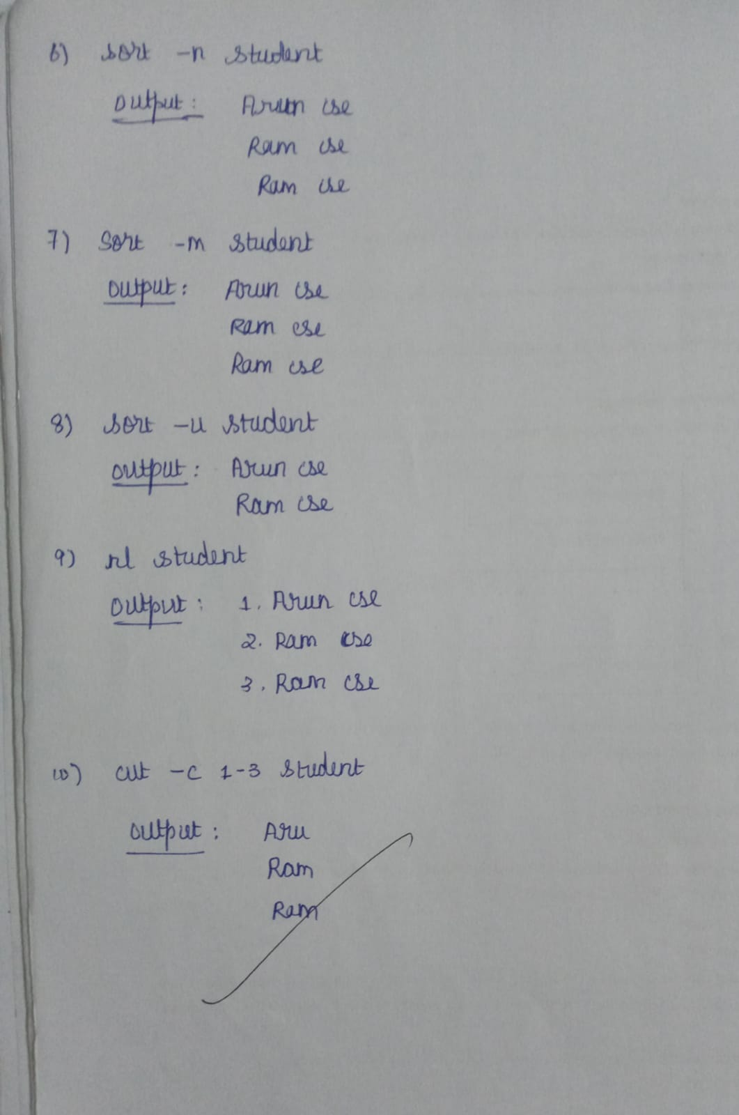

**OTHER COMMANDS:**

